AI/ML-Based Predictive Maintenance and Vehicle Health Monitoring System
1. Introduction
Predictive maintenance uses vehicle sensor data and machine learning to identify abnormal operating conditions before they lead to component failure. This project develops an AI/ML-based predictive maintenance and vehicle health monitoring system for electric vehicles (EVs).
The system uses telemetry such as battery voltage, battery temperature, motor temperature, motor vibration, motor RPM, torque, power consumption, brake pressure, driving speed, distance travelled, and charge cycles. These parameters are processed and given to machine learning and deep learning models to estimate the probability of failure.
The implemented system compares Logistic Regression, Random Forest, XGBoost, and LSTM models. The final system converts the estimated failure probability into a vehicle health score and generates a maintenance status.

2. Objective
The main objectives of this project are:
- To analyse EV telemetry data for predictive maintenance.
- To use important vehicle parameters for failure prediction.
- To compare Logistic Regression, Random Forest, XGBoost, and LSTM.
- To evaluate the models using accuracy, precision, recall, F1-score, and ROC-AUC.
- To identify important vehicle parameters using XGBoost feature importance.
- To convert model-estimated failure probability into a vehicle health score.
- To generate maintenance alerts based on the estimated vehicle condition.

3. Dataset Description
The project uses the EVIoT Predictive Maintenance Dataset, obtained from Kaggle. The dataset contains 175,393 records and 30 columns of EV telemetry data.
The data includes battery, motor, braking, tire, environmental, driving, and maintenance-related information.
The timestamped records allow the data to be analysed as a time series, which is particularly useful for the LSTM model.
Table 1. shows the main Predictive Features selected for this project.
CATEGORY | SELECTED PARAMETERS
Battery | Battery Voltage, Battery Current, Battery Temperature
Motor | Motor Temperature, Motor Vibration, Motor RPM, Motor Torque
Energy | Power Consumption
Braking | Brake Pressure
Driving | Driving Speed, Distance Travelled
Usage | Charge Cycles
The target variable is Failure_Probability, where 0 represents no failure and 1 represents a failure condition.
The dataset contained no missing values.
The failure distribution was approximately 90% non-failure and 10% failure, providing substantially more failure examples than the initial dataset considered for this project.
Figure 1. Failure Class Distribution − how many normal vs failure records are present.
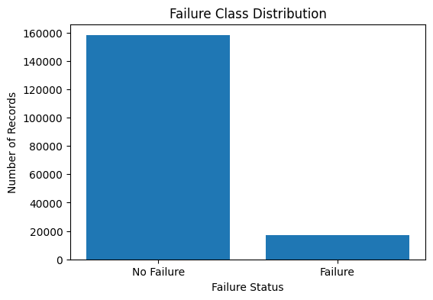

4. Methodology
System workflow:
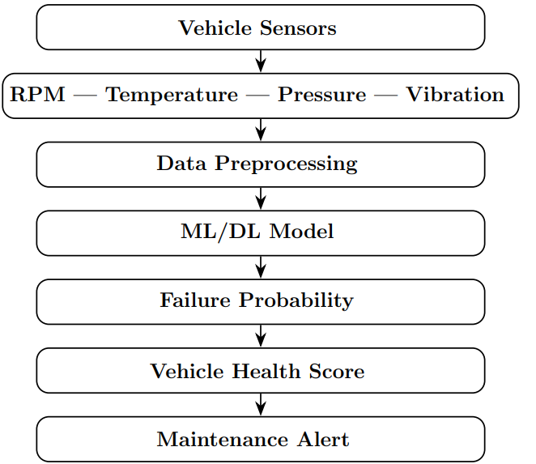

5. Data Preprocessing
The Timestamp column was converted into datetime format and the dataset was sorted chronologically. The selected sensor parameters were separated from the target variable.
To prevent future observations from being used during training, the dataset was divided chronologically into 80% training data and 20% testing data.
The resulting datasets contained:
- Training: 140,314 records
- Testing: 35,079 records
StandardScaler was fitted on the training data and then applied to the testing data for Logistic Regression and LSTM. Random Forest and XGBoost were trained using the original feature values.
Because failure records were less frequent than normal records, class weighting was used for Logistic Regression and Random Forest, while XGBoost used scale_pos_weight. For the LSTM, balanced class weights were calculated from the training sequences.
For temporal learning, the LSTM used 10 consecutive observations as one input sequence. Since each observation represents a 15-minute interval, each sequence represents 2.5 hours of vehicle telemetry.

6. Machine Learning Models
Four models were implemented.
6.1 Logistic Regression
Logistic Regression was used as a baseline classification model to establish a simple reference performance.
6.2 Random Forest
An ensemble of decision trees capable of learning non-linear relationships between vehicle parameters and failure conditions.
6.3 XGBoost
A gradient-boosting model used for classification. Class weighting was applied to give greater importance to the less frequent failure class.
6.4 LSTM
A recurrent neural network designed for sequential data. It uses consecutive vehicle telemetry observations to learn temporal patterns that may indicate changing vehicle conditions.

7. Model Results
Table 2. shows Accuracy, Precision, Recall, F1-score, and ROC-AUC evaluations for each model.
MODEL | ACCURACY | PRECISION | RECALL | F1-score | ROC-AUC
Logistic Regression | 0.5475 | 0.0979 | 0.4334 | 0.1598 | 0.4932
Random Forest | 0.9007 | 0.0000 | 0.0000 | 0.0000 | 0.5068
XGBoost | 0.6163 | 0.1047 | 0.3797 | 0.1642 | 0.5162
LSTM | 0.6501 | 0.1013 | 0.3205 | 0. 1539 | 0.5037
The comparison shows how traditional machine learning models and a sequence-based deep learning model perform on the same predictive maintenance task. Accuracy is considered together with recall, F1-score, and ROC-AUC because the failure class is smaller than the non-failure class.
Figure 2. ROC Curve Comparison of ML and DL Models.
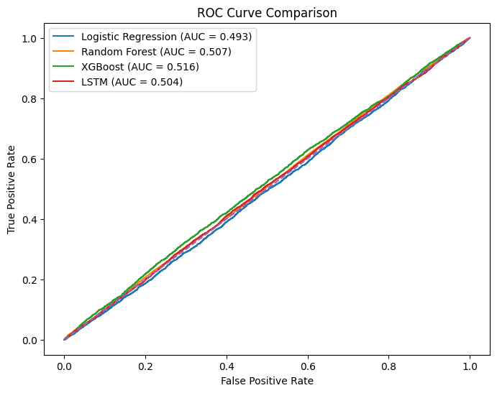
Figure 3. Performance Comparison of ML and DL Models.
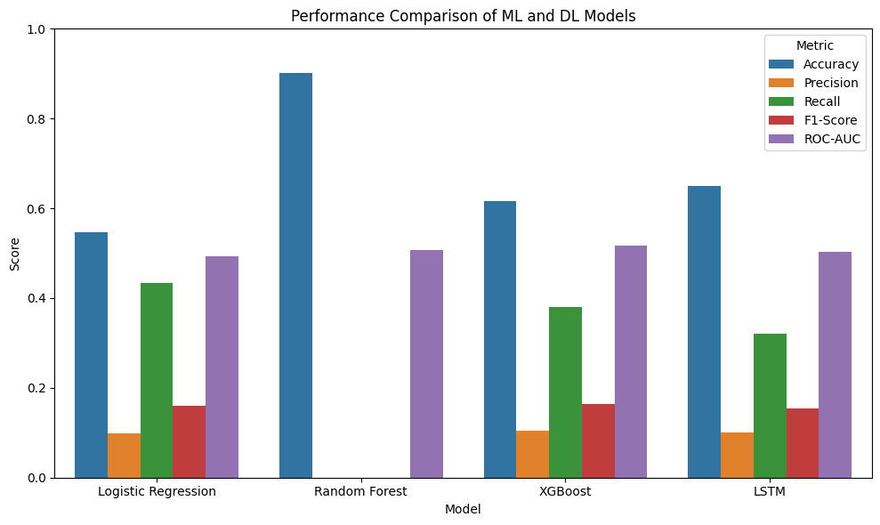
The confusion matrices provide an additional view of correctly and incorrectly classified failure and non-failure records.
Figure 4: Confusion Matrices of the following models:
LOGISTIC REGRESSION RANDOM FOREST XGBOOST
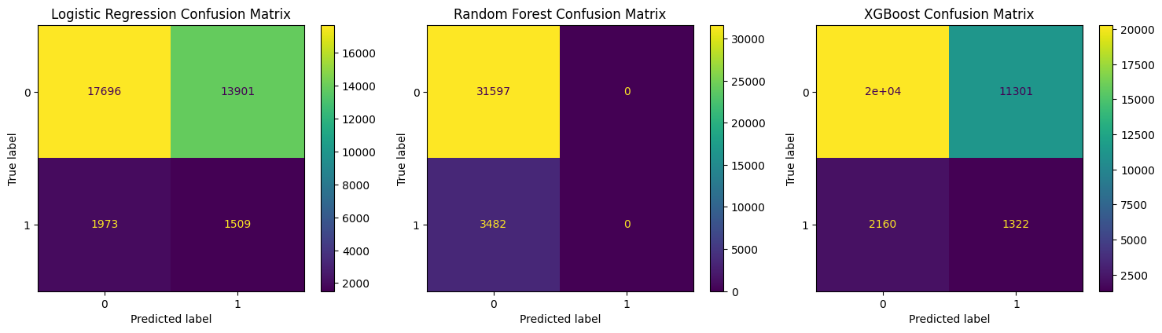
Figure 5: Confusion Matrix of LSTM model.
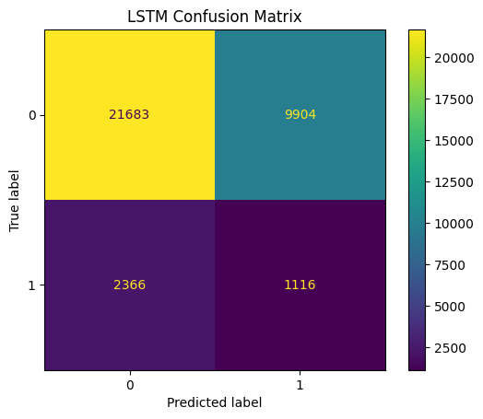

8. Vehicle Health Monitoring
The trained XGBoost model is used as the predictive component of the vehicle monitoring system. For each test observation, the model produces an estimated failure probability.
A health score is calculated as:
Vehicle Health Score = (1 − Estimated Failure Probability) × 100
Table 3. shows all the Thresholds used in this project.
HEALTH SCORE | STATUS | MAINTENANCE ACTION
≥ 70% | NORMAL | No immediate maintenance alert
40–69.99% | WARNING | Maintenance inspection recommended
< 40% | CRITICAL | Immediate maintenance attention required
These thresholds are project-defined thresholds and are not intended to represent industry-standard limits.
Figure 6. Real-Time Vehicle Health Score, Failure Probability, and Maintenance Status.
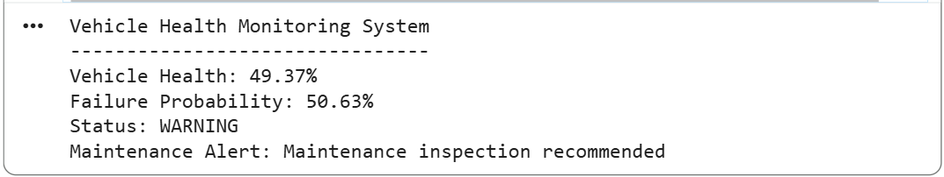
The output displays the estimated failure probability, vehicle health score, status, and corresponding maintenance recommendation.

9. Explainability
XGBoost feature importance was used to identify which vehicle parameters contributed most to the model's predictions.
Table 4. shows Importance values of XGBoost Feature.
INDEX | FEATURE | IMPORTANCE
0 | Battery_Voltage | 0.084442
4 | Motor_Vibration | 0.084166
6 | Motor_Torque | 0.084001
9 | Driving_Speed | 0.083977
10 | Distance_Traveled | 0.083622
3 | Motor_Temperature | 0.083582
11 | Charge_Cycles | 0.083579
2 | Battery_Temperature | 0.083544
1 | Battery_Current | 0.083433
8 | Brake_Pressure | 0.082651
7 | Power_Consumption | 0.082178
5 | Motor_RPM | 0.080825
Figure 7. XGBoost Feature Importance for Vehicle Failure Prediction.
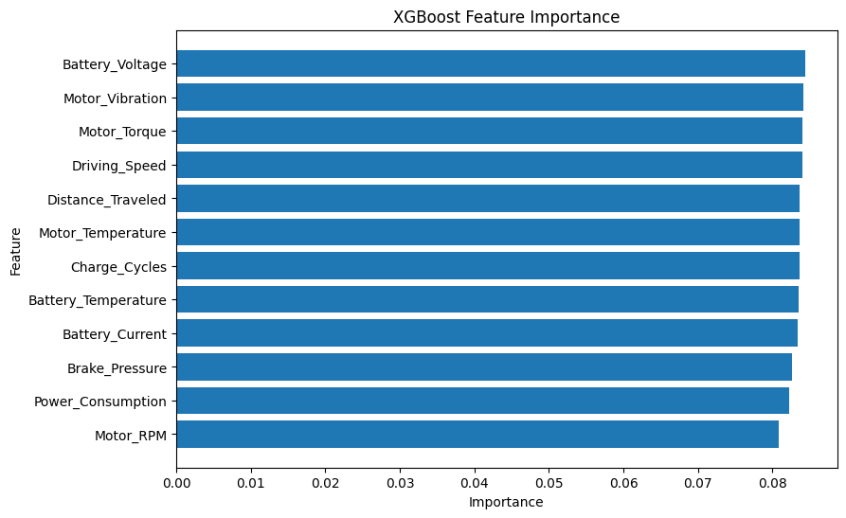
The feature-importance results help interpret which telemetry variables the model relies on when making predictions. These values represent model importance and should not be interpreted as proof of direct causation.

9. Discussion
The project demonstrates a complete predictive-maintenance pipeline, starting from EV telemetry and ending with a vehicle health and maintenance recommendation.
The dataset provides a substantially larger number of observations than the initial dataset considered for the project and contains a broader range of EV-specific parameters. The chronological train-test split also provides a more realistic evaluation setup for time-dependent vehicle telemetry.
The comparison of Logistic Regression, Random Forest, XGBoost, and LSTM allows both conventional machine learning and deep learning approaches to be evaluated. The feature-importance analysis further provides an interpretable view of the parameters used by the XGBoost model.
However, model performance must be interpreted carefully because the dataset is still imbalanced and is a prepared predictive-maintenance dataset rather than live vehicle sensor data. The estimated failure probability represents the model's prediction on this dataset and should not be treated as a guaranteed real-world probability.

9. Limitations
- The dataset is based on EV telemetry rather than live data collected from the user's vehicle.
- The failure classes are imbalanced.
- The dataset's predefined failure-related variables may not represent every real-world vehicle failure scenario.
- Model-estimated probabilities are not necessarily calibrated real-world probabilities.
- XGBoost feature importance indicates the features used by the model but does not establish causation.
- The health-score thresholds used in the monitoring system are project-defined.

10. Conclusion
This project developed an AI/ML-based predictive maintenance and vehicle health monitoring system using EV telemetry data. The system processes multiple battery, motor, braking, driving, and usage parameters and compares Logistic Regression, Random Forest, XGBoost, and LSTM models for failure prediction.
The final monitoring pipeline converts the model's estimated failure probability into a vehicle health score and generates a maintenance status. XGBoost feature importance also provides an interpretable view of the vehicle parameters used by the predictive model.
Overall, the project demonstrates how machine learning and time-series deep learning can be integrated into a vehicle health monitoring pipeline to support early identification of potential failure conditions and maintenance planning.

11. References
- EVIoT Predictive Maintenance Dataset, Kaggle.
- Scikit-learn Developers, Logistic Regression Documentation.
- Scikit-learn Developers, Random Forest Classifier Documentation.
- XGBoost Developers, XGBoost Documentation.
- TensorFlow Developers, LSTM Layer Documentation.

